20BCG10053-Aakash Gupta

20BCG10081-Anas Ahmad Khan

Having an audio-video scene and buttons. (tutorial)

Step 1: create a scene

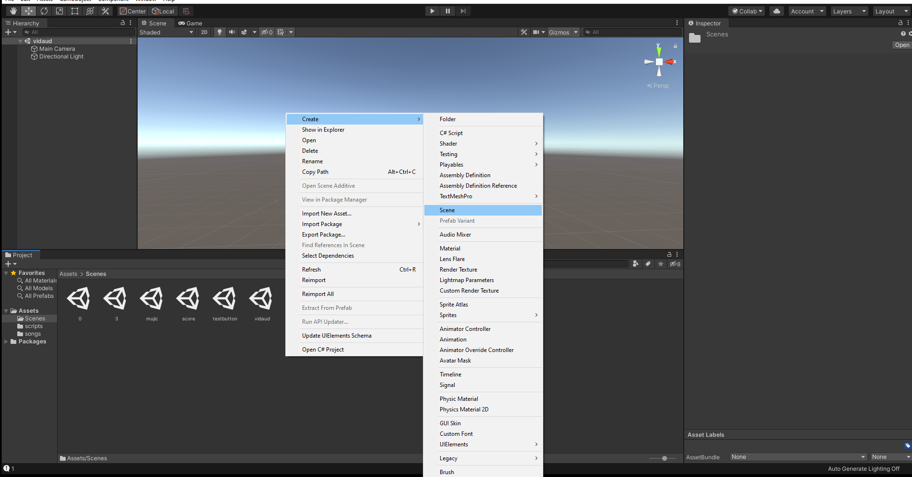

Step2: Create 3 button play, pause, stop.

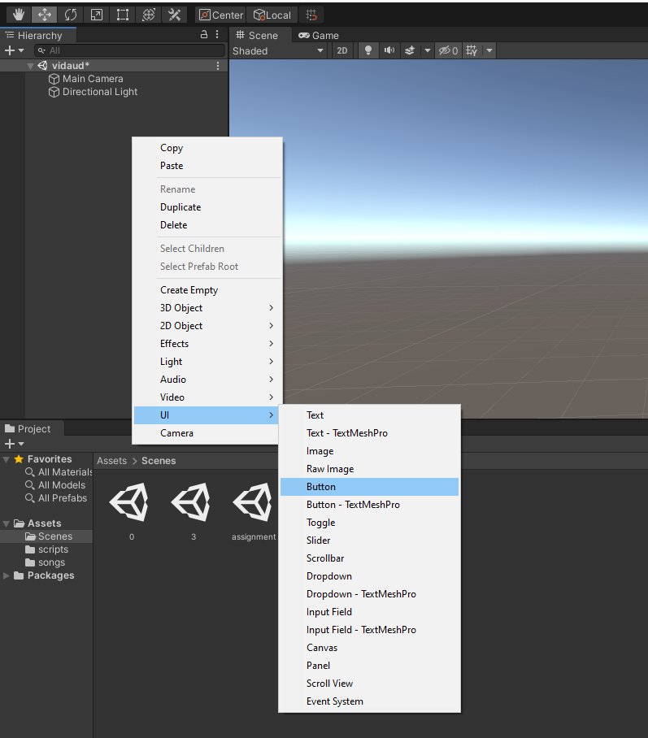

Step 3: create text

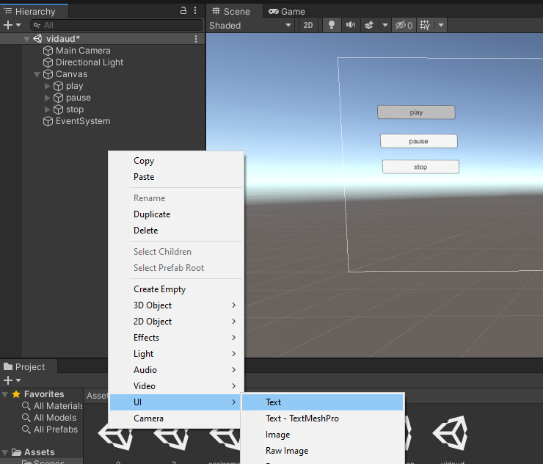

Step 4: setting up scene.

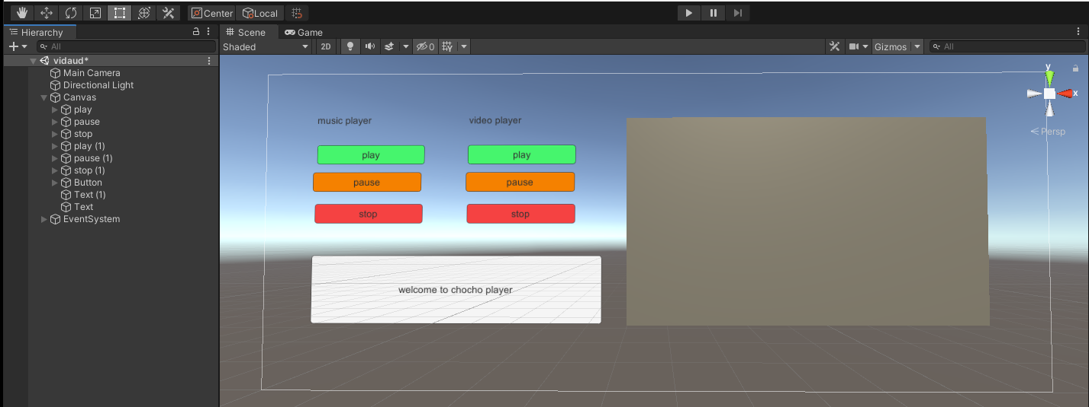

Step 5: create empty object to add sound

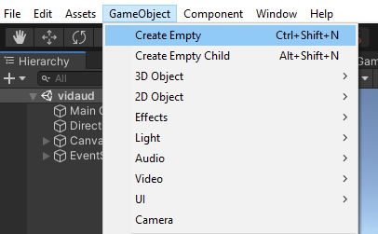

Step 6: drag audio to empty game object

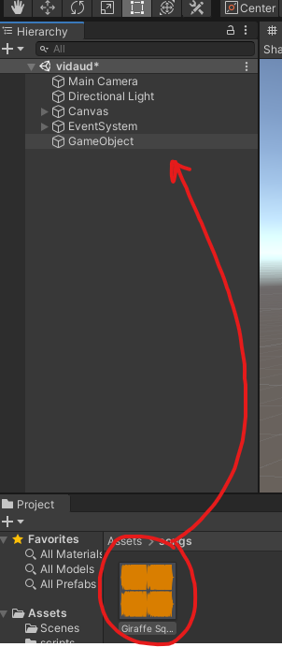

Step 7:drag game object and add to on click action on button 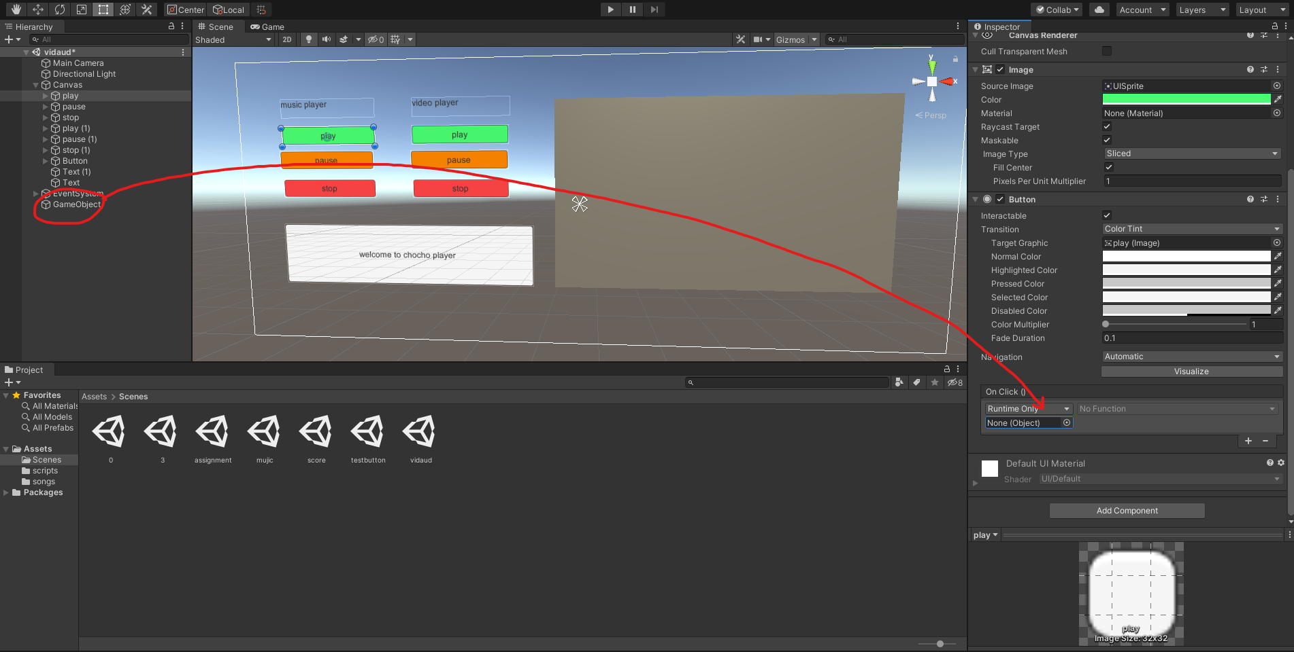Step 8: untick play on awake.

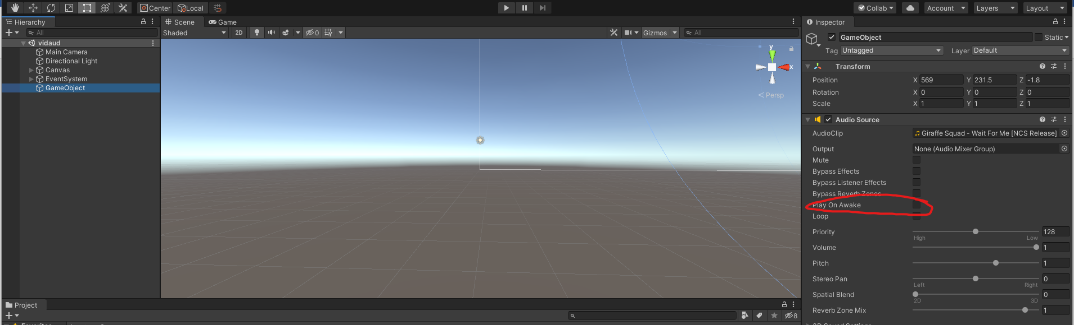

Step9: Adding function to the buttons.

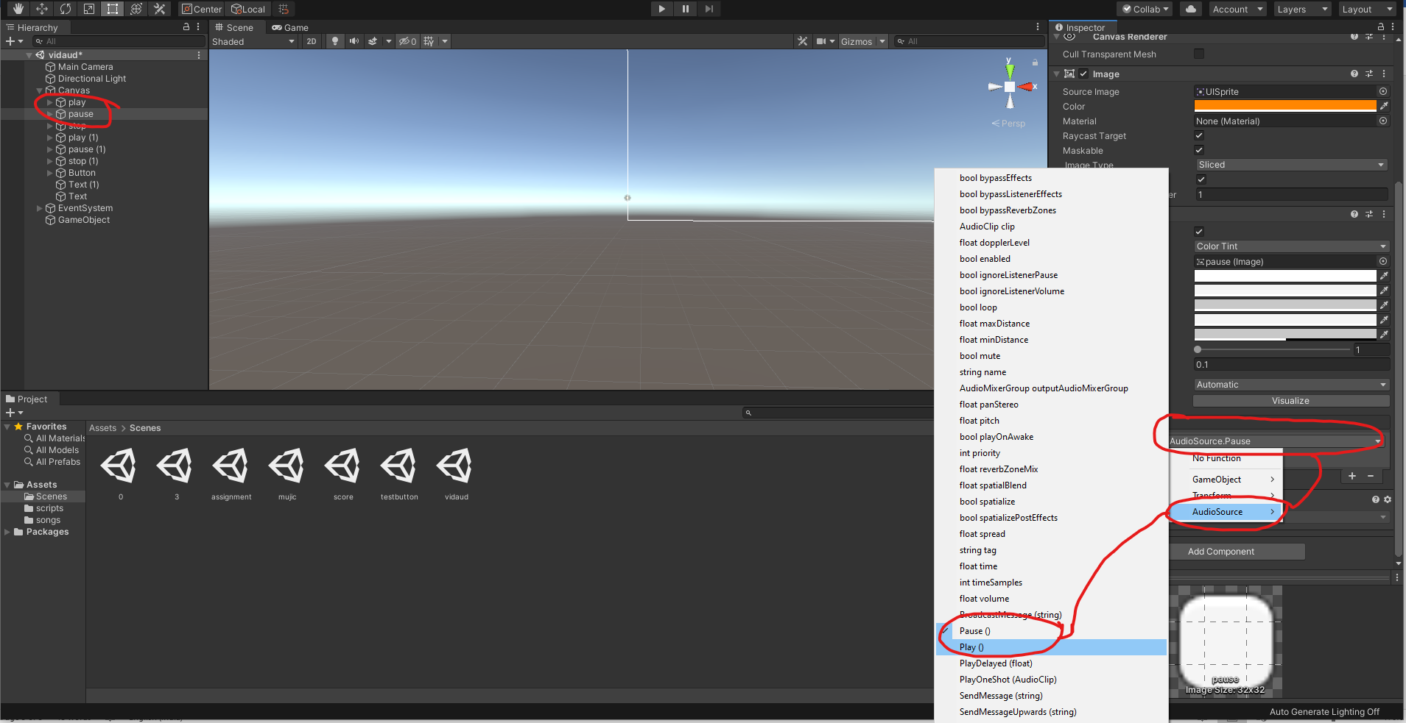

Step10: create a cube add to event system.

add video to the cube

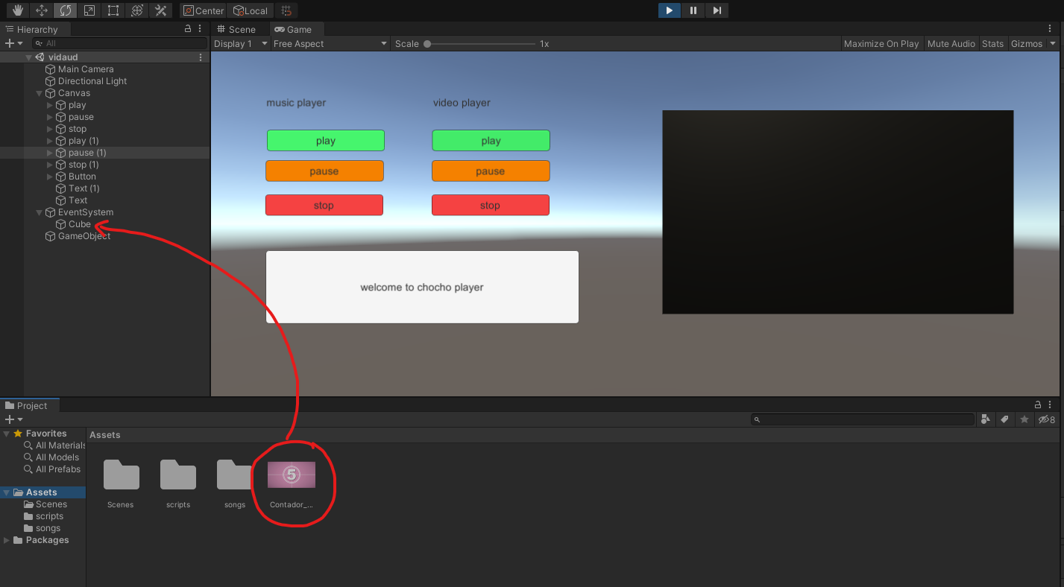

Step11: drag cube to the button

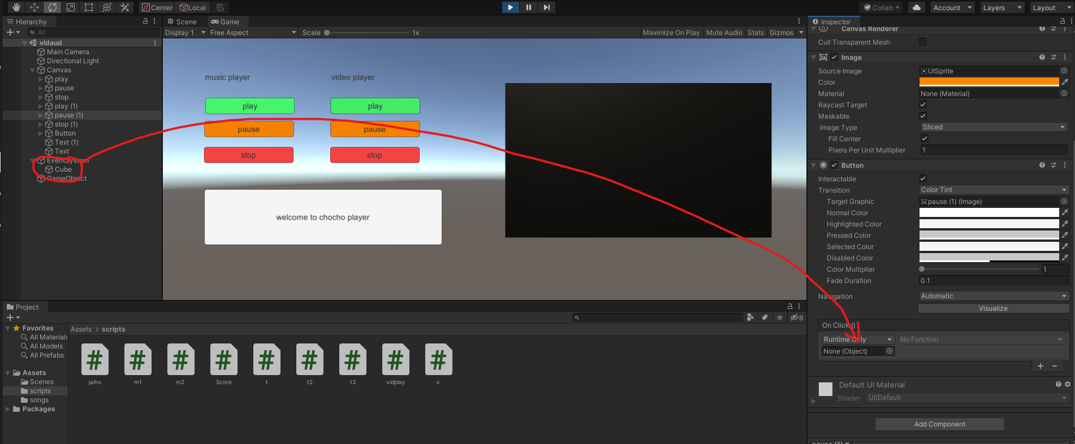

Step 12: adding function to the button

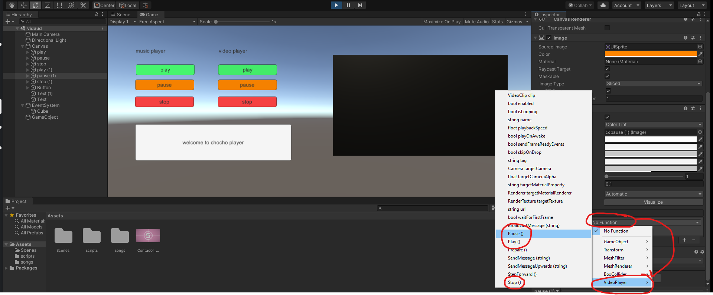

Preview

